1. Read the question and the student’s answer carefully.
2. Use the mark scheme to award the student a number of marks and annotate their answer with suggestions to improve.
Stretch: Rewrite the answer to show how it should be done!

Question:
Copper sulfate solution was electrolysed.
Explain why a solid forms at the negative electrode.
(4)
Student answer:
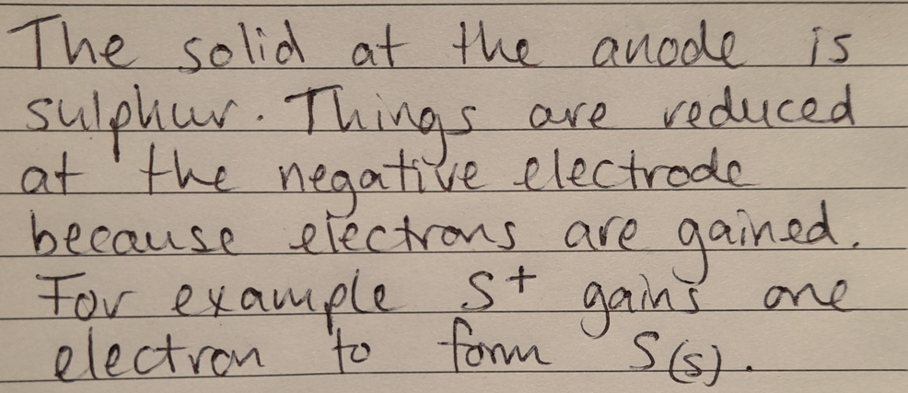

Marks awarded= _________

Mark scheme:

Answer | Mark
Copper ions (Cu²⁺) are attracted to the negative electrode/cathode | 1
Copper ions are reduced/gain electrons | 1
To form copper atoms | 1
Copper metal is formed | 1

